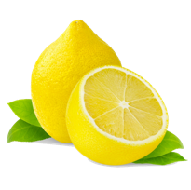
Women’s Ministry
April 17, 2017
The Salvation Army
Lubbock, Texas

Welcome & Prayer

Lemon & Chopstick Relay

29 Benefits of Drinking Lemon Water

Sharing in “Lemon Delights”

Lemon Promises: God’s Promises to Us

Life lessons from Lemon Drops of Queen Esther

Closing Prayer

